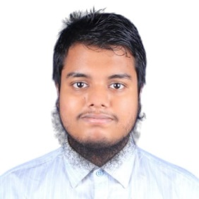
MD MAHBUBUR RAHMAN SHEIKH
Address: Basilla, Mohammadpur, Dhaka – 1207, Bangladesh
Mobile: +88 01715230943
Email: mahabub.sheikh2001@gmail.com
Career Objective
A motivated and detail-oriented Statistics graduate seeking an opportunity to apply analytical and problem-solving skills. Eager to contribute to data-driven decision-making and grow professionally in a dynamic environment.
Education
Level | Subject | Institute | Board/University | Examination Year | Result
SSC | Science | Dhanmondi Govt. Boys’ High School | Dhaka | 2017 | 5.00 out of 5.00
HSC | Science | Mohammadpur Govt. College | Dhaka | 2019 | 4.08 out of 5.00
B.Sc.(Hons.) | Statistics | Dhaka College | University of Dhaka | 2023 | 3.05 out of 4.00
Training and Workshop
- Microsoft Office Training, UY Lab for 3 months in 2023
- Aspire Leadership Program, Aspire Institute for 2 months in 2025
Special Skills
- Leadership  - Good communication skills.  - Excellent presentation skills  - Customer service  - Sales and marketing | - Team work  - Public speaking  - Good organization skills and the ability to work under pressure  - Microsoft Office Application
Language Skills
- English – Good professional proficiency in reading, writing, listening and speaking
- Bengali – Native
IT/Technical Skills
- Good working proficiency in Microsoft Word, Excel, PowerPoint presentation, email and internet browsing.

